RAYEES AHMAD

Senior CAD Engineer

E mail: rayees.ahmad.ifa@gmail.com

Contact: +91-9716626092,8851672812

OBJECTIVE:

To work as a [CAD Drafter](http://www.bestsampleresume.com/sample-manufacturing-resume/autocad-drafter-resume.html)  where my manual & CAD drafting experience with drafting software and AutoCAD can help in durable and feasible structural designs as well as create and modify 2D 3D isometric and technical drawings.

ACADEMICS QUALIFICATION:

Examination

passed

B. E

Intermediate

SSC

Discipline

Mechanical

Engineering

PCM

-

College/University

Corporate inst. of science

& technology, Bhopal

I.D.B.P.S. College,

B.S.E.B. PATNA

S.S High School,

B.S.E.B. PATNA

Year of passing

2014

2010

2007

% of marks

62.9%

61.8%

63.2%

WORK EXPERIENCE:

• Company:

• Company:

•

•

•

•

•

•

•

Smart Brains engineering & Technology Pvt Ltd Noida Duration: 11 Jun 2014 to 30 Jun 2017

Dimension india pvt ltd noida Duration: 03Jul 2017 to till date.

Experience: 3 Years

Designation: Senior CAD Engineer

Department: Quality

Project: Air filter, Boiler, Piping designing, P&ID Layout, SLD, Solar Energy, solar plant designing.

Profile: AutoCAD 2d,3d & isometric.

Current Salary: 20 K CTC

Expected Salary: As Per Industries.

JOB RESPONSIBILITY:

•

•

•

•

All mechanical and electrical drawing through Auto CAD preparing there 2d & 3d isometric.

Task will involve updating and creating 2d drawing of structural, layout and equipment

including part drawing.

Coordinate work with other disciplines such as Mechanical/Electrical/Planning Dept.

Co-ordination with clients & vendors for reviewing the drawing.

CERTIFICATION:

•

•

•

Autodesk Certified user with Auto Cad.

Autodesk Certified user with Auto Cad 360 Fusion.

Mechanical Draftsman Trainer in National Skill Development Corp. (Government of India)

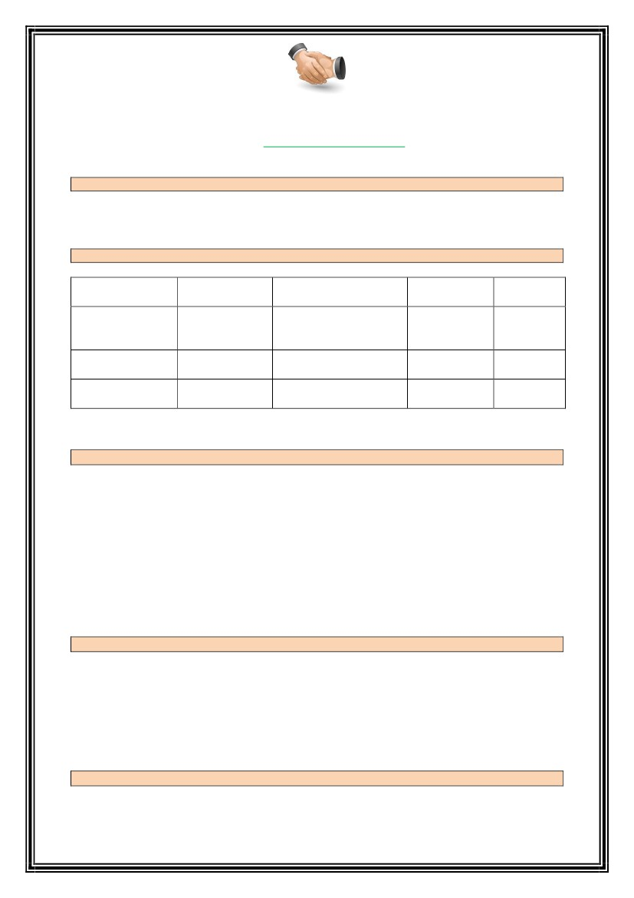

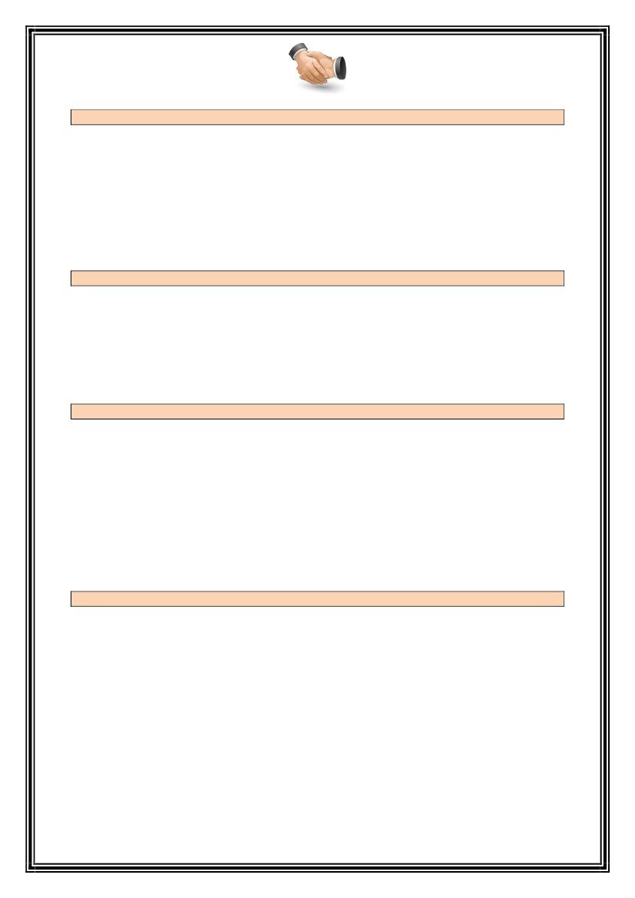SKILLS:

•

•

•

•

•

•

•

Drawing sheet their layout and planning.

Orthographic projection & drawings.

Isometric projection & drawings.

Section and convection.

Machining symbols and surface texture.

Theory of tolerance.

Detail and assembly drawing of various parts, pipe joint and valves.

TECHNICAL SKILLS:

•

•

•

•

•

Engineering cad software.

AutoCAD 2010,2013,2016,2017

Good knowledge of 2d drawing.

Knowledge of AutoCAD 360 Fusion.

Knowledge of Microsoft word and excel.

PERSONAL PROFILE:

Name

Father’s name

Gender

Date of Birth

Religion

Nationality

Marital status

Languages Known

Address

:

:

:

:

:

:

:

:

:

Rayees Ahmad

Mr. Afzal Hussain

Male

03-10-1992

Islam

Indian

Single

English and Hindi

Rasulpur Bithwan

DIST- Rohtas Bihar

DECLARATION:

I promise to put in my best efforts in achieving the objective of your esteemed organization in an

optimum way with all of my abilities and skills and I assure you my sincerity and loyalty in

discharging my duties.

RAYEES AHMAD